**Updates for LAAD’s web page – 2017**

**ENGLISH**

**# 1: changes to complete in Home page: http://www.laadsa.com/**

1. Year number in text of Developmental Impact

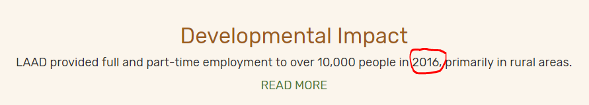

Replace with: 2017

1. Amount of Disbursement

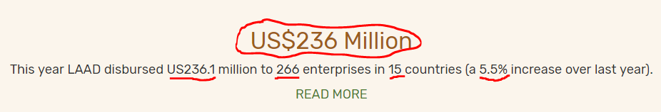

2.1 Replace 236 with 239.5

2.2 Replace text so it states as follows:

In 2017 LAAD disbursed US239.5 million increasing the agribusiness loan portfolio by 11.2%.

1. Statistics

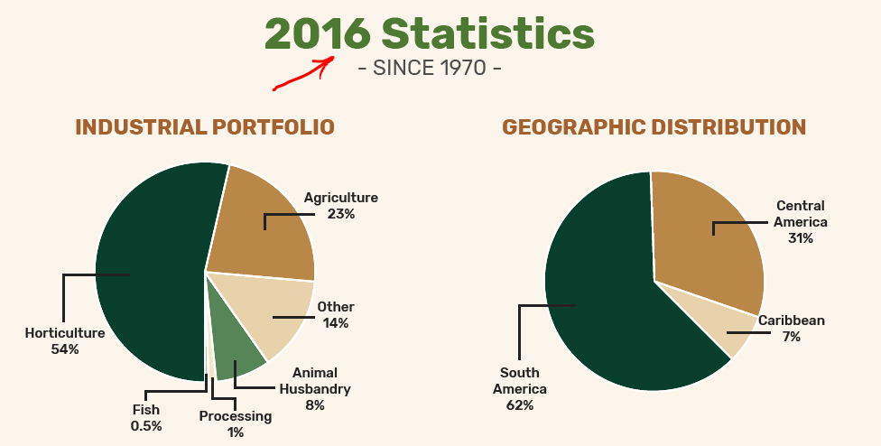

* 1. Replace 2016 with 2017
  2. Replace current pie chart with the following (taken from annual report):

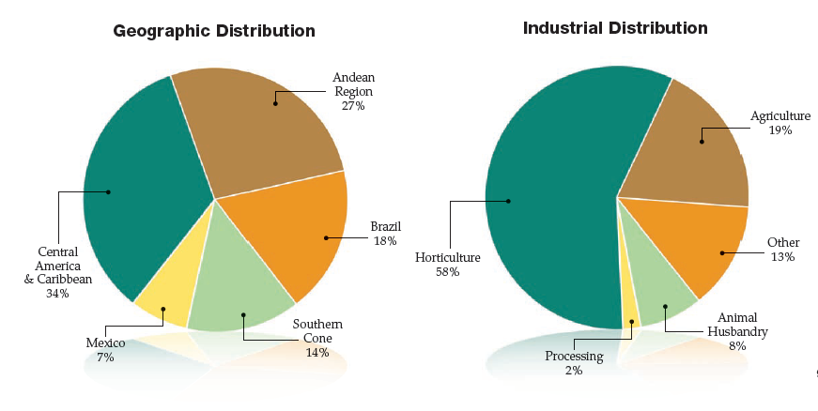

Please be sure to maintain the color and format of the current title of the charts





* 1. Replace the following:

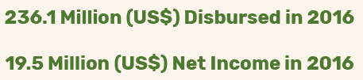

So it states as follows:

239.5 Million (US$) Disbursed in 2017

20.3 Million (US$) Net Income in 2017

**# 2: changes to complete in Shareholders: http://www.laadsa.com/shareholders.html**

1. Logo update: use this same order to display logos

(logos taken from annual report)

   

   

  

**# 3: changes to complete in Letter to Shareholders: http://www.laadsa.com/letter-to-shareholders.html**

1. Replace current letter to Shareholders with the following text (taken from Annual Report page 2):

Multiple factors affected the agribusiness industry on a worldwide level in 2017, and Latin America was not the exception. Extreme weather events, including devastating floods in the Dominican Republic and Peru, powerful hurricanes Irma and Maria in the Caribbean, and the catastrophic earthquake in Mexico, forced farmers and lenders to cope with extraordinary circumstances. Political issues, such as the effect of the US elections in Mexico and the Odebrecht corruption case in the Western Hemisphere, further complicated the already challenging business landscape. High global liquidity levels drove the influx of capital into the region, forcing financial institutions in certain markets to reinvent their strategies. For LAAD in particular, this meant lowering our rates to remain competitive.

By all indications, the agribusiness industry will continue to evolve beyond 2017. On the production side, the farming community is in the midst of major shifts, including the effects of climate change on the usual dynamics of the farming cycle, forcing farmers to take more measures against external variables beyond their control, which leads to higher productions costs and, for the less fortunate, going out of business. Another consequential development is the consolidation of the entire agribusiness value chain into bigger and fewer players (including producers as well as suppliers of agricultural inputs), which will

change the balance of power, redefining winners and losers. Urbanization is yet another factor significantly affecting rural communities, as farmers and agribusiness companies in Latin America struggle to find laborers to work at the field level and maintain the farming tradition and legacy within families for future generations.

On the consumer side, new players are entering into the food system. Innovative methods to purchase food are being introduced (such as multiple e-commerce platforms) and novel ways to consume food (in terms of quality, type, packaging and delivery) are becoming available to cater to the preferences and

demands of educated and discerning millennial consumers.

Without a doubt, our clients and farmers are facing exceptional challenges in addition to the usual problems they experience on a daily basis. Despite the increasing demand for food in the world to feed the growing population and the additional purchase power of the majority of the consumers at the low end of the pyramid, especially in emerging markets, there are and will be hurdles to overcome. LAAD will continue to support farmers as they embrace the use of technology to adapt to and remain competitive and sustainable in this unpredictable environment.

Once again, geographical and industry diversification proved to be the best insurance against natural disasters, as even under these circumstances your Company achieved a record disbursement of US$239.5 million to 305 projects in 15 different countries and created over 10,000 new jobs. Additionally, it will generate over US$170 million per year in foreign currency for the region. The Company took over US$182 million in term loans and lines of credit from local and international financial institutions to finance portfolio growth. It surpassed last year’s net income by 4% and achieved 11% growth, and – most significantly – attained an average return on equity of 12%. This year, we will also embark on a new entrepreneurial endeavor, as we plan to enter into Argentina for the first time.

On October 27, 2017, AgriTellus Investments LLC, a company owned by Benjamin Fernandez III and

LAAD’s Senior Management, bought JPMorgan’s ownership in LAAD, thus becoming one of the twelve LAAD shareholders. We believe that this purchase not only reinforces Management’s commitment, but also further aligns the goals of Management and Shareholders.

We are optimistic about what tomorrow holds, as our history of tenacity and resilience will support our present decisions and inspire our future success. We will face each new challenge with confidence

and ingenuity, armed with the knowledge acquired through almost half a century of experience and encouraged by the gratification of being part of a Company that drives progress and promotes innovation while maintaining the mission, values and culture that define us.

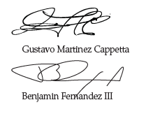

**# 4: changes to complete in Letter from LAAD’s President: http://www.laadsa.com/letter-from-the-president.html**

1. Name of the section:
   1. Replace: Letter From LAAD’s President

So it will state: Note from the PRESIDENT

(must replace in 2 occasions: in the dropdown and in the top of the text)

* 1. Edit hyperlinks name in order not to show anymore: <http://www.laadsa.com/letter-from-the-president.html>

It should from now on state: http://www.laadsa.com/Note-from-the-PRESIDENT.html

6.3 Text for the current Note from The PRESIDENT:

Upon concluding my first year as CEO of LAAD, I would like to recognize the people who have been significant throughout my professional career.

I am indebted to Colleen Nissl, Chairman of the Board at the time, who persuaded me to accept the role of Chief Financial Officer.

I am also grateful to Marcelo Melchior, who was Chairman of the Board at the time I was elected CEO, and the other members of the Board of Directors for their trust and confidence in my ability to serve as the third President & CEO of LAAD.

My sincere thanks to the LAAD family and our clients for being the heart and soul of LAAD.

I am the grateful and humble beneficiary of the legacy formed by my predecessor and current Chairman of the Board, Benjamin Fernandez III, who taught me the most important lesson I have learned during my time at LAAD, which is that it’s all about people, as “Projects don’t pay – people do.”

Last but never least, I thank my wife and daughter for always being there for me in the brightest and darkest moments.

Gustavo Martinez Cappetta

**# 5: changes to complete in Loan Portfolio: http://www.laadsa.com/loan-portfolio.html**

1. Update of pie charts (taken from annual report)

Please this:

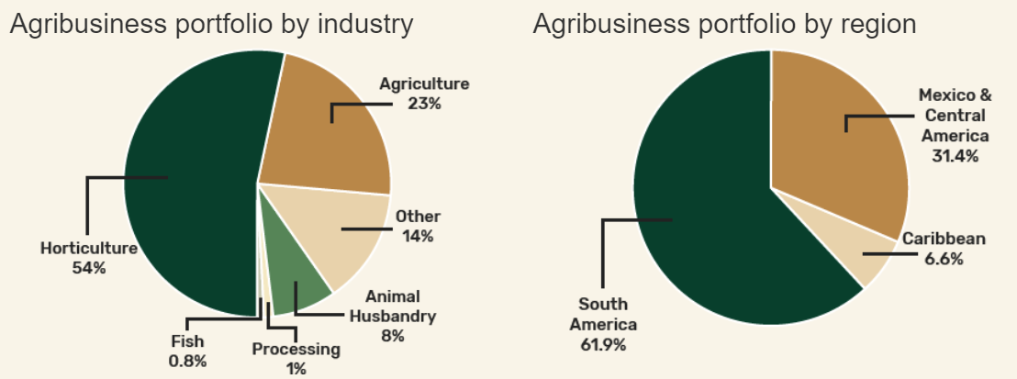

With this:

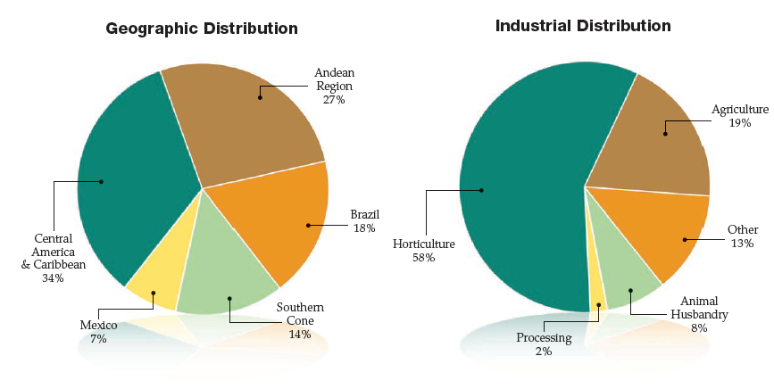

**# 6: changes to complete in Funding:** [**http://www.laadsa.com/funding.html**](http://www.laadsa.com/funding.html)

1. Delete from the page this tab so that Funding it’s no longer available

**# 7: changes to complete in Disbursements:** [**http://www.laadsa.com/disbursements.html**](http://www.laadsa.com/disbursements.html)

1. Edit graph
   1. Delete the following:

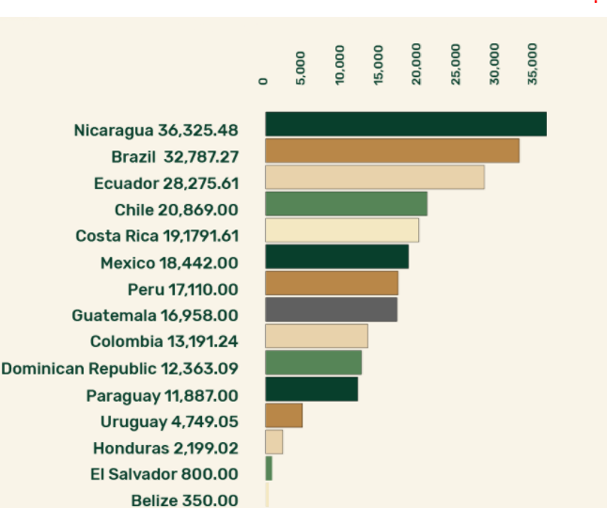

Replace it with the following (from annual report):

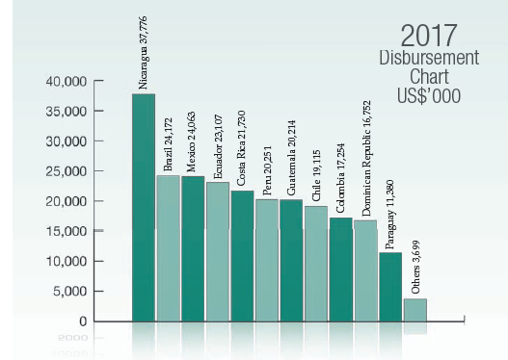

* 1. Text below the graph must be replaced with the following:

(Taken from pg 5 of the annual report)

During 2017, Latin America, our region of operations, continued to experience similar challenges to those in 2016. Some countries faced adverse weather conditions, while others suffered from political turmoil. Heavy rains and hurricanes affected countries like Peru and the Dominican Republic, destroying thousands of hectares of crops. Brazil, Ecuador and Mexico were affected by internal and external political situations causing economic complications. On the other hand, Central America had a strong performance, as the region benefited from both political and climatic stability.

In spite of these challenges, LAAD surpassed its 2016 operational results in both loan disbursement and net income levels. These record levels were fueled by 305 disbursements in 15 different countries reaching over US$239.5 million. The projects financed by LAAD in 2017 created over 10,000 new jobs and US$170 million per year in foreign currency for the region.

Projects involving coffee led the way, with 17% of total disbursements during the year. Banana, cattle and soybeans followed with 14%, 8% and 7%, respectively. The four products represented 46% of total disbursements. The remaining volume was constituted by various other products. As a result, LAAD’s agribusiness loan portfolio grew by 11.7% on a year-to-year basis, reaching a record US$745 million at the end of fiscal year 2017.

**# 8: changes to complete in Developmental Impact: http://www.laadsa.com/developmental-impact.html**

1. Text update:



It will state the following:

In 2017, the projects financed by LAAD created over 10,000 new jobs. LAAD-financed projects also generated an additional US$170 million in annual foreign exchange to Latin America.

* 1. Charts update:

This are the updated charts, please kindly replace:

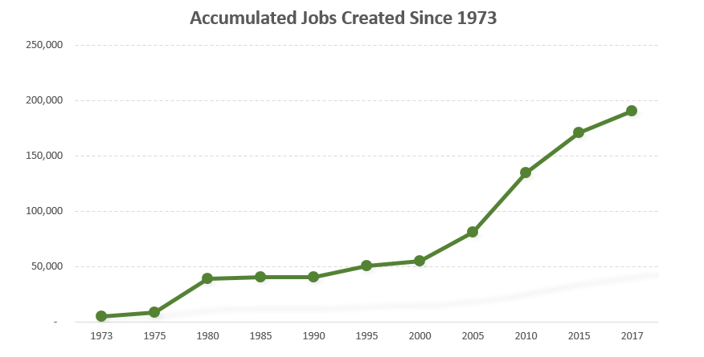

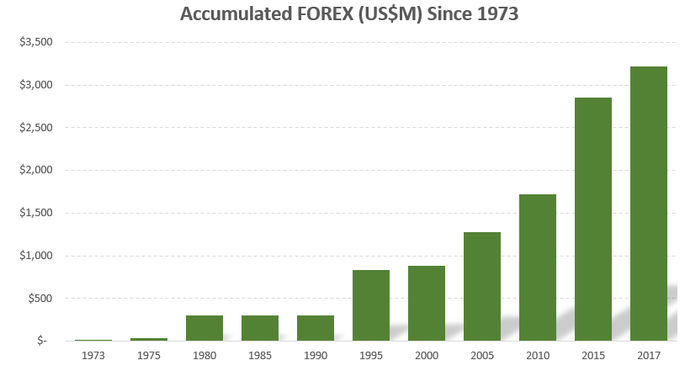

**# 9: changes to complete in Annual Reports and Brochures: http://www.laadsa.com/download-annual-report.html**

1. Include 2017 annual report in the list of options to download

**# 10: FORMAT update/corrections**

1. In Highlighted Projects: <http://www.laadsa.com/projects.html>
   1. Chile - Frutícola Montegiallo

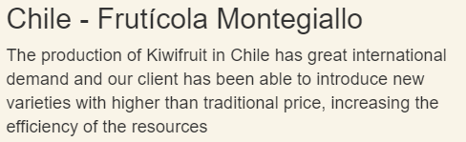

Add a **period** at the end of the paragraph

* 1. Costa Rica - Agroindustrial Las Mellizas

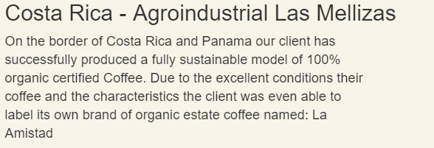

12.2.1: Add a **coma** after the Word Panama

12.2.2: **Replace**: 100% organic certified Coffee

With: 100% certified organic coffee

(all lower case)

12.2.3: **Replace**: Due to the excellent conditions their coffee and the

characteristics the client was even able to label its own brand

of organic estate coffee named: La Amistad

With: Due to the excellent conditions and characteristics the

client was able to label its own brand of organic estate coffee

named: La Amistad.

12.2.4: Add a **period** at the end of the paragraph

* 1. Ecuador – Agricola Angy Rose

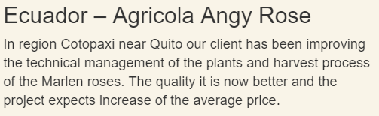

Add a **coma** after the word: Quito

* 1. Mexico – Grupo Industrial Anguiano

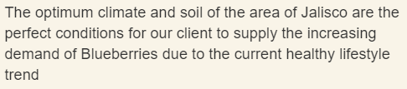

Add a **period** at the end of the paragraph

1. Format correction in <http://www.laadsa.com/developmental-impact.html>

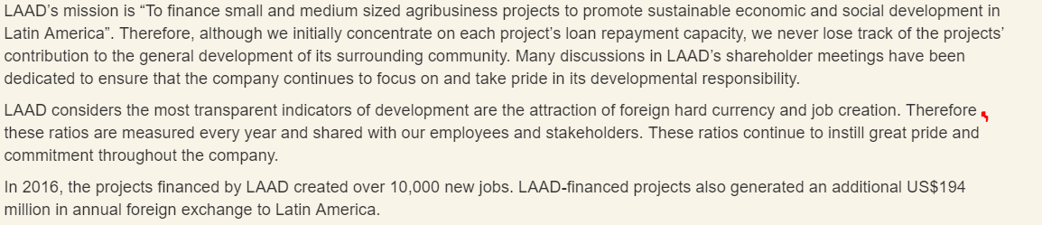

Add a **coma** after the word: Therefore - in the 2nd paragraph

1. Format correction in: homepage

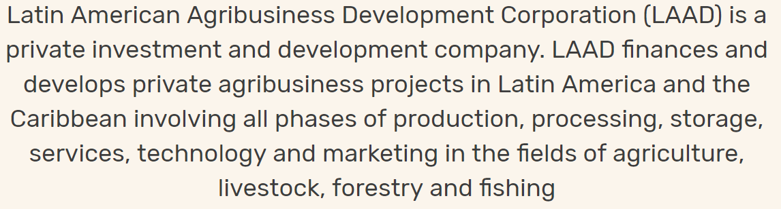

Add a **period** at the end of the paragraph